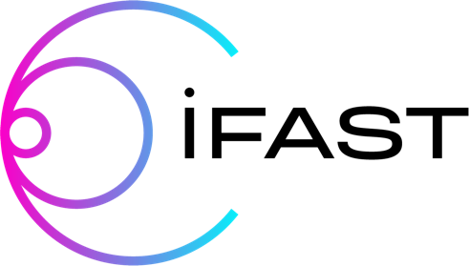
Innovation Fostering in Accelerator Science and Technology

I.FAST Traineeship Programme
Please fill in and send by latest 1 April 2022 the submission form here below to
Tord.Ekelof@physics.uu.se and Antoine.le.gall@cern.ch

Introduction
The EU-supported project I.FAST announced a traineeship programme to support knowledge transfer of new component technologies between laboratories and industry.
The programme offers the opportunity for an early-career engineer or technician working at a European industrial company to work as trainee at one of the I.FAST European Accelerator Development Laboratories for a duration of 2 weeks to 3 months. The traineeship will put emphasis on knowledge transfer in the development, design and testing of new advanced technological components for frontline accelerator and magnet research infrastructures.
The programme covers the costs for the duration of the traineeship of:
- Salary
- Travel
- Subsistence

Application process
The proposal shall be submitted by the Industrial Company and the I.FAST Laboratory in common and describe on one or two pages:
- The project and the technology with which the industrial engineers and technicians shall work at the I.FAST Laboratory;
- How this work will lead both to training of the engineer or technician and transfer of knowledge of new component technology from the I.FAST Laboratory to the Industrial Company;
- How the Industrial Company intends to make use of the knowledge thus acquired for its business.
The deadline for application is 01/04/2022.

Selection process
The applications shall be judged by an I.FAST Expert Selection Committee based on:
- Relevance of the interest of the Company to acquire the knowledge and experience of the technology.
- Professional merits of the proposed engineer or technician.
- Level of knowledge and experience of the I.FAST Laboratory and, in particular, of the intended trainee supervisor at the Laboratory for the proposed project and the associated component technology.
- The quality and effectiveness of the training program being proposed.
- Consistency between the proposed training activity with the amount of salary, travel and subsistence support requested for the trainee and the proposed duration.
- The expected outcomes of the technology transfer of the trainee project.
- The terms of the training will be regulated through a written agreement between the I.FAST Laboratory and the Industrial Company.
At the conclusion of the trainee secondment, the Laboratory and the Company shall together submit a report on the outcome of the training period to the Expert Selection Committee.
The written proposal should be submitted by email to:
- The I.FAST Task 2.4 Chair, prof. Tord Ekelof (Tord.Ekelof@physics.uu.se) with copy to Antoine Le Gall (Antoine.le.gall@cern.ch).
A decision will be communicated to the proponents within 3 months of submission of a proposal.

I.FAST Laboratory  Name:  Address:  Name of the representative  Role:  Email: | Industrial Company  Name:  Address:  Name of the representative  Role:  Email:
Application form to be submitted before 1 April 2022 to Tord.Ekelof@physics.uu.se and Antoine.le.gall@cern.ch
Date:
Proposed industrial trainee
Name:
Email:

- Description of the project and the technology with which the industrial engineers and technicians shall work at the I.FAST Laboratory.
Text

- Description of how this work will lead both to training of the engineer or technician and transfer of knowledge of new component technology from the I.FAST Laboratory to the Industrial Company.
Text

- Description of how the Industrial Company intends to make use of the knowledge thus acquired for its business.
Text

